Wilson Tennis Ball
Price: Approximately RS 8,999
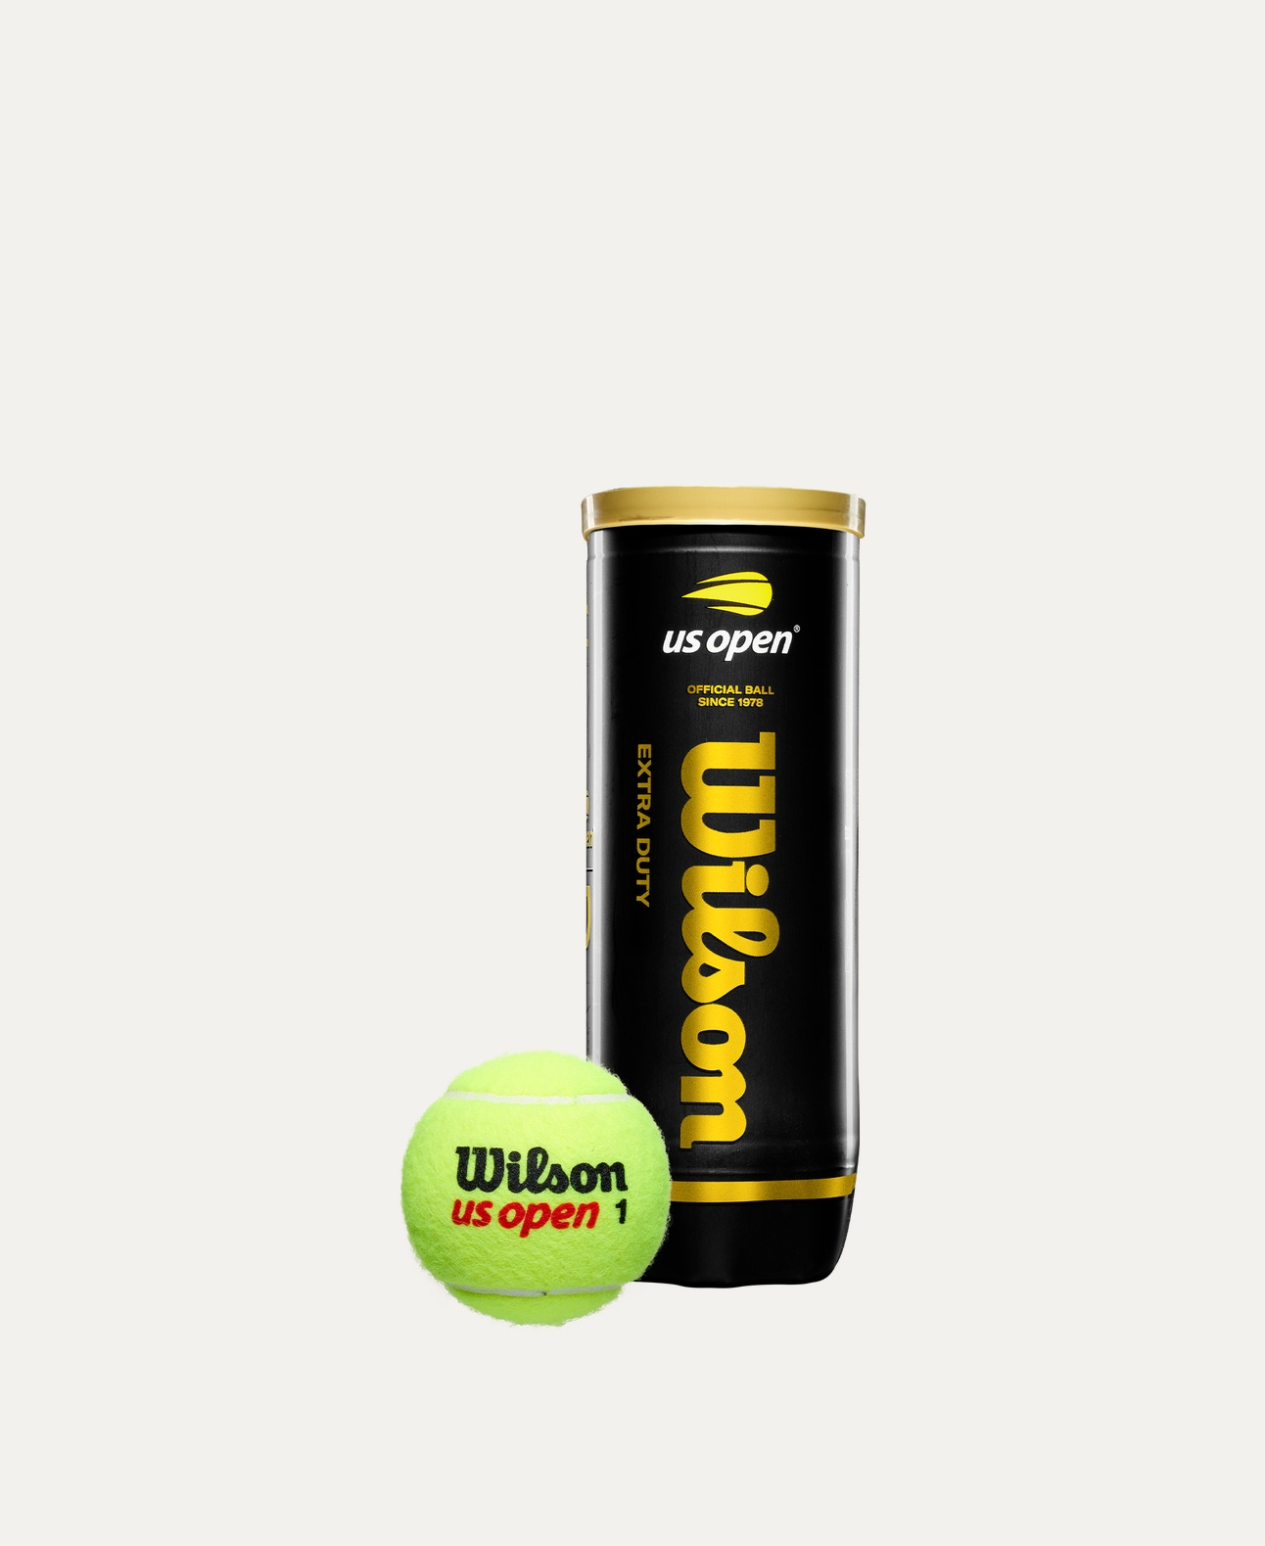
Introduction
Wilson Tennis Balls are designed to deliver consistent bounce, durability, and control on the court. Trusted by players worldwide, these balls are ideal for both practice sessions and competitive matches.

Product Overview
These Wilson Tennis Balls are manufactured using high-quality felt and rubber to ensure reliable performance on different court surfaces. They provide excellent playability and maintain pressure for longer use.

About the Brand
Wilson is a globally recognized sports brand known for producing premium tennis equipment. Used in professional tournaments and training academies, Wilson products are synonymous with quality and performance.

Key Features
- Consistent bounce and flight
- High-quality felt for smooth play
- Long-lasting pressure retention
- Suitable for multiple court surfaces
- Approved for training and match play

Design & Build Quality
The balls feature a uniform round shape with tightly woven felt for improved aerodynamics. Their solid construction ensures stable performance throughout extended rallies.

Storage & Capacity
Available in sealed cans or bulk packs, making them easy to store and transport while maintaining freshness and pressure.

Material & Durability
Made from premium natural rubber core and durable felt covering, Wilson Tennis Balls are built to withstand regular play and rough court conditions.

Ideal For
- Beginner to professional tennis players
- Training sessions and tournaments
- Tennis academies and clubs
- Hard, clay, and grass courts

Care Instructions
- Store unopened cans in a cool, dry place
- Close the lid tightly after opening
- Avoid exposure to extreme heat
- Replace balls when bounce decreases

Product Specifications
- Brand: Wilson
- Product Type: Tennis Ball
- Material: Rubber core with felt covering
- Quantity: Available in multiple pack sizes
- Court Type: All-court
- Usage: Training & Match Play

Product Summary
Wilson Tennis Balls offer reliable performance, durability, and consistent playability. Whether for practice or competition, they are an excellent choice for players who demand quality and control on the court.

Thank you

